Discussion Questions on Concurrency (Introduction + Locks)

- How does the thread creation interface presented in this chapter differ from fork()?
- What is a race condition? How are race conditions and critical sections related?
- How does mutual exclusion prevent race conditions? How does atomicity prevent race conditions?
- Why are atomic instructions an impractical solution, by themselves, to prevent race conditions?
- Why do we need locks? What are the possible states of a lock?
- What are the semantics of a call to lock()? What are the semantics of a call to unlock()?
- What three metrics do we use to measure the correctness of a lock implementation?
- What are the drawbacks of implementing locks by disabling interrupts?
- What is spin waiting? Is it possible to implement simple spin lock with software based method?
- What does it require from the hardware to implement spin lock?
- How do test-and-set and compare-and-swap differ?
- What are the drawbacks of spin lock? What is the advantage of ticket locks over simple spin-locks?
- What are the pros and cons of spin lock versus a blocking lock (like locks with queues). What is a hybrid or two phase lock?
- Answer the below questions with respect to the following implementation of Queue lock:

(a) Why test-and-set guard instead of flag?

(b) Why it is okay to spin on guard than spin waiting in general?

(c) In lock() why release of guard is done before the park()?

(d) In unlock(), why not set flag=0 when unpark?

(e) What is the race condition here?
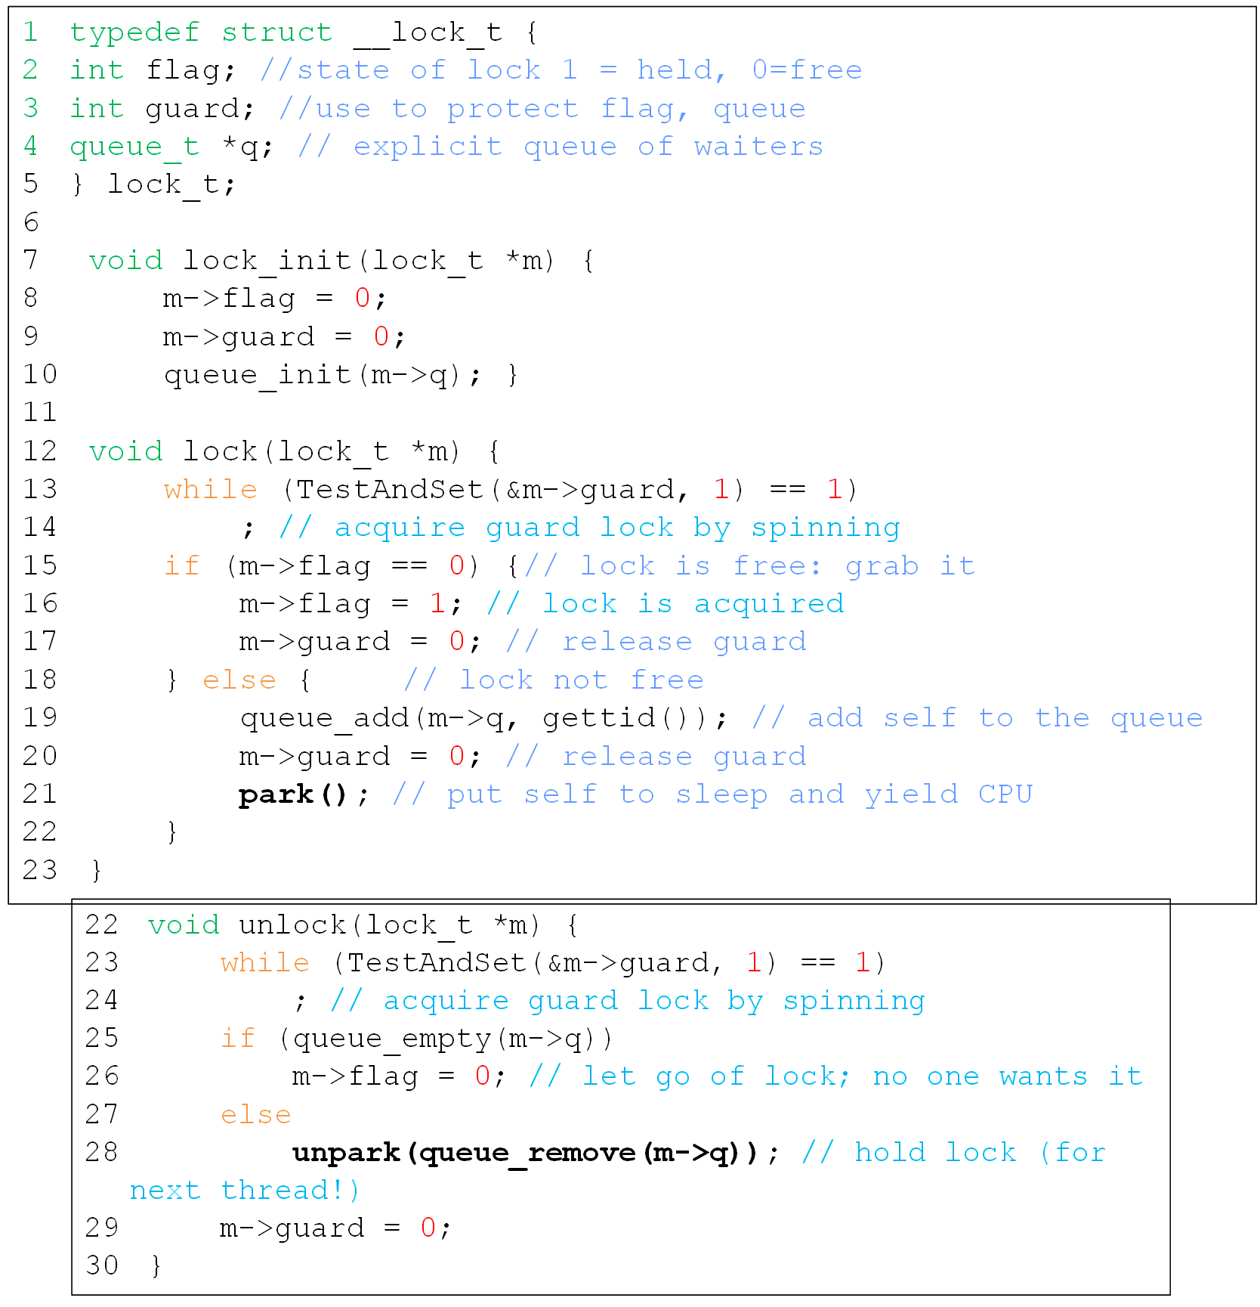
Practice Problems

Q1. Recall that a spin lock acquire() can be implemented with a special atomic exchange instruction as follows:
while (xchg(&lock, 1) == 1) ; // spin

Suppose a subtly different way to implement lock acquire() is as follows:
while (1) {
while (lock > 0) ; // spin
if (xchg(&lock, 1) == 0) return;
}
Explain whether this lock would work or not? What kind of difference(s) does this new lock make?

Q2. In class, we discussed the following code (of Peterson algorithm) as an implementation of mutual exclusion among two threads (with pid 0 & 1):
boolean lock[0] = lock[1] = false;
int turn = 0;
void deposit (int amount) {
lock[pid] = true;
turn = 1 - pid;
while (lock[1-pid] && (turn == (1 - pid))) ; // spin
balance = balance + amount; //critical section
lock[pid] = false; }

Let’s say we replace the statement turn = 1 - pid with the statement turn = BinaryRandom(), where the function BinaryRandom() returns a 1 or 0 at random to whomever calls it.

a) Will the code still function properly? If so, why, and if not, what problem could occur (explain)?

b) Now write the pseudo-code for implementation of mutual exclusion among N threads and explain its working.
Q3. Consider the following attempt to implement software solution to two thread critical section problem. In this, when one thread finds that the other thread also intends to enter its critical section, it sets its own intendToEnter flag to false and waits for the other thread to exit its critical section.
______T0 ______________T1 _____________
while (true) { while (true) {
intendToEnter0 = true; (1) intendToEnter1 = true; (1)
while (intendToEnter1) { (2) while (intendToEnter0) { (2)
intendToEnter0 = false; (3) intendToEnter1 = false; (3)
while(intendToEnter1) {;} (4) while(intendToEnter0) {;} (4)
intendToEnter0 = true; (5) intendToEnter1 = true; (5)
} }
critical section (6) critical section (6)
intendToEnter0 = false; (7) intendToEnter1 = false; (7)
non-critical section (8) non-critical section (8)
} }

Explain whether this one is a correct solution. If not, explain which of the requirement is not satisfied.

Q4. Consider the following multi-threaded program with two threads. Here is the initial state of some variables in the program:
int g = 10;
int *f = NULL;
Here are the code snippets for each of two threads:
Thread 1 Thread 2
lock (m);  f = &g;  unlock (m);//S1  ... // do some other stuff  lock (m); //S2  printf ("%d\n", *f);  unlock (m); | lock (m); f = NULL; unlock (m);

- What are all the possible outputs of the system, given an arbitrary interleaving of Threads 1 and 2?

- Inspite of using locks around critical sections is there any "undesirable things" happening. in part (a)? If we remove statement S1 and S2 in code for Thread 1, will it be better or worse?

Now, let's examine another program, again with two threads:
Thread 1 | Thread 2
pending = 1; === = | pending = 0;  = 0;
while (pending) {
printf("hello\n");
}
(d) What are the possible outputs of this system, given an arbitrary interleaving of Threads 1 and 2?
(e) How could we re-write the code such that Thread 2 would only run after "hello" has been printed at least one time?

